**China’s Economic Transformation**

Term 1 Paper

Shu Wang Lo (596874)

“Depict the essential features of China’s reformed economic system after 1978. How far do they represent a break with the pre-reform system?”

2190 Words

***Summary***

A series of economic and political reforms had been carried out in China since 1978, each with the goal of improving the economic system that was having difficulties providing even basic living necessities to the population. The essential features of the reformed economic system in China hence are dependent on the two distinct stages of transformation, first the formation of township and village enterprises (TVE) in the rural areas, usually collectively owned, and then the large scale creation of private enterprises in both urban and rural areas, by privatizing state enterprises and TVE’s, or the growth of new private enterprises. This is substantially different from the overwhelmingly dominant planned economic system, where state enterprises dictated urban economic activities and communes being responsible for rural agricultural and minimal basic industrial activities, right before the reforms.

1. **Introduction**

In the last forty years or so, China grew from one of the countries with the lowest per capita GDP in the world to a high middle income country, apparently as a result of a series of econo-political reforms and accompanying policies introduced by the central government. There has been a rich collection of literature on this journey. One of the sources of data can be found from the World Bank databank, as illustrated by the GDP vs year data presented in Figure 1. The timing of the stages of reforms is also indicated in the figure. There is little doubt among the global economic community that these reforms are closely related the GDP growth.

The focus of this essay, however, is on the final shaping of the reforms of the economic system, and how different it is from the one when the journey started. With reference to the focus, this essay will examine the essential features of the reformed economic system and the difference from the previous system, from the perspectives of ownership structure, labor distribution and GDP contribution of each ownership entity group. Since any significant economic system transformation is inevitably accompanied by the change in industrial structures, which on the other hand can hinder the real impacts of the transformation, this essay also includes a discussion of the evolution of the industries. A comparison with the economic system before the reforms is then provided.

**Figure 1:** GDP growth of China since 1960 (in current US dollars). The timing of the reforms are also indicated. Data taken from [Worldbank1].

1. **Transformation of the economic system from 1978**

In 1979, China started the first exploratory economic system reform in the rural area by allowing the formation of township and village enterprises (TVE), as an experiment to energize the economic system that was failing to provide the basic necessities to the vast population [RISKIN1]. The TVE’s are basically enterprises collectively owned by farmers in the rural areas. In 1979, rural areas were administered by communes, which were responsible for managing the agricultural activities of the rural population and at the same time fulfilling production quotas given by the state. The TVE’s owned by the communes then became the vehicles for generating additional income for the members, while fulfilling the state production quotas. TVE’s were mainly engaged in commodity productions using simple equipment. Although product qualities were usually basic, the price of the products was in general lower than those produced by state owned enterprises (SOE’s), and TVE’s could actually make good incomes for the members [LAU1].

This new policy became an important incentive for the rural communities. Millions of TVE’s were established in the following decade. That decade also saw the conditions of the SOE’s deteriorated, due to their inability to complete with the TVE’s on commodity price. By the early 1990’s it was clear that there was a need to start the second stage reform in the urban areas, where the majority of the SOE’s are located.

The first stage reform did not generated significant growth in GDP, but it was an important experiment for the second stage reform. The second phase of reform was characterized by (a) allowing market regulation of the foreign exchange rate, (b) private ownership on the basis of a new Company Law, and (c) the separation of commercial and central banks (The People’s Bank) as a way to control the accumulating bad credits to SOE’s.

While (a) has a lot of impacts on the international trades and industrial upgrading, as will be explained later, (b) and (c) effectively made most of the SOE’s independent (except those identified to be of critical national security values, such as entities in military, financial and certain technology sectors), in terms of profit and loss. Consequently, a massive number of SOE’s, as well as TVE’s, were privatized, became publicly owned or bankrupted in the next 10 years, and this trend continues even today. The second stage reform hence caused the shifting of the economic system from a planned economy to a market economy [WU1].

This shift is illustrated by the dramatic reduction in SOE employees since 1995, as given in Figure 2. Although the population did grow in the last twenty years, the number of people employed by SOE’s in 2005 was less than 40% of its peak in 1995. Another demonstration of the impacts of reform is demonstrated in Figure 3, which plots the GDP contribution of each ownership type. The contribution to the GDP by privately owned entities accelerated from the mid-1990, whereas the GDP contribution of SOE’s and TVE’s was reduced substantially in the same period of time. Part of the essential features of the reformed economic system in China can then be summarized as pre-dominantly market economy, based on the enterprise ownership, GDP contribution and number of employment characteristics. However, this is not the full picture of the economic system in the post-reform economy, since China also went through drastic changes in its industrial structure since 1978.

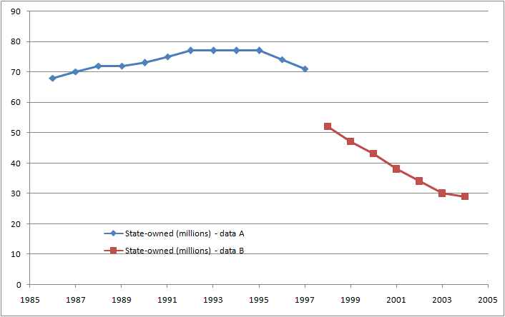

**Figure 2:** Labor employment by SOE. Data taken from [NAUGHTON1]. Original data from Statistical Yearbook of China (various years) and statistics published by the Ministry and Labor and Social Security (various years).

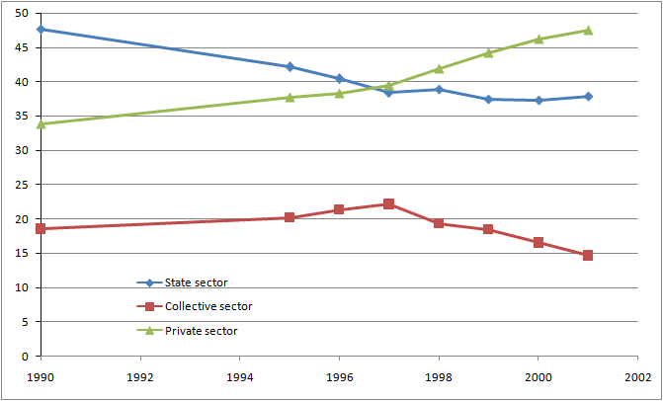

**Figure 3**: Percentage contribution to GDP by different sectors of the economy. Data taken from [WU1]. Source data from China Statistical Yearbook and CEIC Databank. Private sector includes all rural and urban economic entities that are not part of the state or collective sectors, e.g. foreign owned entities.

In addition to allowing foreign exchange rate to be market regulated, China was also accepted as a member of World Trade Organization (WTO) in 2001. Both of these on the one hand allowed China to have higher access to the global markets, attract more foreign direct investments and foreign enterprises into China, establish a sizable export-oriented manufacturing sector (as can be seen in Figure 4) and more integrated into the global market economy system, and on the other hand enabled China to acquire foreign technologies, increase per capita productivity and accelerate domestic industry upgrading into higher-value add, capital intensive sectors. Although the private sector was found to have increased allocative efficiency in the market, SOE’s were found to substantial increase in productivity in this time period [LO1]. This is also evident from the fact that the contribution of SOE’s to the overall GDP was as high as 36% in 2001, although its employees had been reduced by about 50% (see Figure 2 and Figure 3).

Meanwhile, the contribution to GDP of the primary industry sector, which consisted of mainly agriculture and related economies, decreased substantially from about 30% in 1980 to just under 10% in 2013 (see Figure 5). On the contrary, the GDP contribution of the tertiary industry, i.e. service industry, increase in the same period from about 20% to about 50%. Industry upgrading is hence another important feature of the post-reform economy in China. The essential features of the economic system resulting from the reforms can now be summarized as predominantly market economy with industrial updates and productivity and export-led growth trends.

**Figure 4:** Changes in the export of China, as a percentage of GDP, since the late 1970’s. Export became a major economic growth driving force, especially after joining WTO in 2001. Data from [NAUGHTON2]. Original data from *China Customs Statistics*, Annual, Issue No. 12.

**Figure 5:** Changes in percentage contribution to GDP by each industry sector. Data taken from Statistics Yearbook of China [SYC1, 2, 3, 4].

These features still miss another critical component of the China economy, the role of the state. This is illustrated by the following figures. Figure 6 shows the changes in percentage GDP of state fiscal expenditure on investment and subsidies. Investment has been a powerful state tool for shaping the economic and industrial structures, whereas subsidies have also be the tolls for the same purposes, as well as being the channels the state protected certain segments of critical economic or political importance from being damaged by the transformation process or market pressures. Examples of using these tools included investing in national infra-structures without clear financial return, subsidizing SOE’s when they were not competitive, cultivating technology firms for developing new industries, etc. The extent of their use is hence an indicator of the state in controlling the future of the economy and industries. The percentage GDP based on which these tools were deployed in the reform period actually decreased, as can be seen in Figure 6. Even the total percentage of both tools putting is less than a quarter of that in 1978. However, a calculation of investment and subsidies in the same period, based on the GDP numbers in Figure 4 and the percentage GDP expenses in Figure 6, presented a different story. The total amount of investment and subsidies actually more than doubled between 1978 to 2003 (see Figure 7). Subsidies in particular saw a more than three times increase. It is then clear that the state at lease doubled its efforts trying to manage the economic, political and industrial directions of the country.

**Figure 6:** Changes in the state fiscal expense in investment and subsidies, as GDP percentages, before and after the reforms. Data from [NAUGHTON3]. Original data from Statistical Yearbook of China, 2005.

**Figure 7:** Change in the state fiscal expense in investment and subsidies, as current US dollars, before and after the reforms. Data calculated from Figure 4 and Figure 6.

The features of the economic system in the post-reformed China gave a mixed impression. In one aspect, most of the state and collective owned enterprises had been privatized; commodity production is now dictated by market forces, with price and profitability as the leverage and goals; state does not provide any production planning and instruction anymore; private ownership takes an overwhelming position; the system is intimately integrated with the international market economies; but the state maintains tight controls as to what directions the economic, political and industrial systems are evolving. This is not a socialist economy in the conventional sense. That is why it is branded as socialism with Chinese characteristics by the state.

1. **Comparison between the Pre-reform and Post-reform Economic Systems**

The economic system discussed so far has little resemblance with the one right before it, the pre-reform economic system in 1978. A summary of the differences and similarities is given in Table 1. Most of the features of the post-reformed economy did not exist before hand, except individuals are independent economic actors all the way. Individuals have been responsible for their own consumption, saving and investment choices, the property ownership right that did not exist before 1979 became available [NOUGHTON4].

But then the economic system right before the reforms was only one of the few systems that China practiced in the previous thirty years. Private enterprises and property ownership existed for a short period of time immediately after the establishing of the People’s Republic of China, or in the early 1950’s. That system shares more similarity with the post-reform system. From this perspective, the answer to the question about how different the pre-reform and post-reform systems are can be: it depends on which pre-reform system is under discussion. The system was described as one of the transition steps to socialism.

|  |  |  |
| --- | --- | --- |
| **Entity** | **Pre-reform Economic System** | **Post-reform Economic System** |
| Individual | Independent economic actor | Independent economic actor |
| No property ownership right | Property ownership right |
| Urban enterprise | State, local or collective owned | Private, public, state, collective owned |
| State planned production targets | Independent profit and loss |
| State planned commodity price | Market determined commodity price |
| State planned career path | Independent career efforts |
| Rural entities | Communes organize activities | Individuals responsible for profit and loss |
| Ties with international markets | Minimal | Extensive |
| National economic system | Tightly controlled | Tightly managed |
| National development strategy | Tightly controlled | Tightly managed |

**Table 1:** A comparison of the pre-reform and post-reform economic systems with respect to individual economic activities and ownership rights, enterprise functions, ties with international markets, control of national economic system and development strategy.

1. **Conclusion**

The post-reform economic system in China has the features of private ownership, market driving price, close integrations with international markets and tightly state managed. It is quite different from the system right before the reforms, when state controls all economic activities except individual consumptions. However, it is similar to the system immediately after the establishing of the People’s Republic of China

1. **References**

[LAU1] Lau, L.J., Y. Qian and G. Roland (1999) ‘Reform without losers: an interpretation of China’s dual-track approach to transition’, *Journal of Political Economy*, 108 (1): 120-143.

[LO1] Lo, D. and G. Li (2011) ‘China’s economic growth, 1978-2007: structural-institutional changes and efficiency attributes’, *Journal of Post-Keynesian Economics*, 34 (1): 59-83.

[NAUGHTON1] Naughton, B. (2007) *The Chinese Economy: Transitions and Growth*, ch.4 (Cambridge and London: MIT Press), p. 106

[NAUGHTON2] Naughton, B. (2007) *The Chinese Economy: Transitions and Growth*, ch.16 (Cambridge and London: MIT Press), p. 378

[NAUGHTON3] Naughton, B. (2007) *The Chinese Economy: Transitions and Growth*, ch.18 (Cambridge and London: MIT Press), p. 434

[RISKIN1] Riskin, C. (1987) *China’s Political Economy: The Quest for Development Since 1949*, 1-2 (Oxford: Oxford University Press).

[WORLDBANK1] World Bank databank, <https://data.worldbank.org/indicator/NY.GDP.MKTP.CD?locations=CN>

[WU1] Wu, J. and S. Fan (2015) ‘China’s economic reform: processes, issues, and prospects (1978-2012)’, in G.C. Chow and D.H. Perkins (eds.) *Routledge Handbook of the Chinese Economy*, London, Routledge.

[SYC1] Statistics Yearbook of China, 2001.

[SYC2] Statistics Yearbook of China, 2011.

[SYC3] Statistics Yearbook of China, 2013.

[SYC4] Statistics Yearbook of China, 2015.